****

** [www.risapaparoad@yahoo.com](http://www.risapaparoad@yahoo.com)**

NEWSLETTER

..................................................................................................................................................

***FRIDAY, 21ST OCTOBER, 2022: 20222023 MID-SALVATION TERM EDITION***

***............................................................................................................................................***

|  |  |
| --- | --- |
| ***RED CARPET FOR THE NEWEST PARENTS/PUPILS WHO JOINED THE RIS FAMILY***  **C:\Users\HUMAN RESOURCES\AppData\Local\Microsoft\Windows\INetCache\IE\ZRY2UFTK\Screenshot_20220201-114721_Opera_Mini[1].jpg**  **We are very grateful to all our parents who joined us this term. We will ensure making us your choice school counts now and always. THANK YOU!** | ***OUR CORE VALUES***   * ***RESPONSIBILITY*** * ***RESPECT*** * ***CITIZENSHIP*** * ***COURAGE*** * ***CARING*** * ***FAIRNESS*** * ***TRUSTWORTHINESS*** |
| ***OUR VISION***  To positively impact the lives of our pupils through a well-rounded academic curriculum integrated in Biblical worldview that trains them in the way of the Lord.  ***OUR MISSION***   * To teach and develop children academically and intellectually. * To provide a safe and conducive environment where children can learn and feel protected, healthy and safe; developing well both physically and emotionally. * To provide and equip children with facilities and robust activities that help them develop required social skills for refined global citizenship. * To raise children in the understanding of the word of God thereby nurturing them to be disciplined, God-fearing children through an enriched Biblically integrated curriculum.   **From the Desk of the Head of School.**  We are grateful to God for a successful beginning of the 2022/2023 Academic School Year. We are also grateful to all our new parents and pupils that joined our RIS Family; rest assured that your desires for becoming a part of us will be met if not exceeded, in Jesus’ Name. To our existing parents and pupils from the previous years, we remain indebted to you as your continued patronage has kept us in business over the years. We will not relent in our efforts to uphold and improve on the RIS Brand that has stood us out from the rest.  Our IT Room has been overhauled and now has brand new laptops for our pupils to work with. More books have been added to the ones in the E.R.I.C Haven so each pupil has a book to read during the class.  As we go on our half-term break, please help ensure that your children rest very well and have some study time in-between their fun activities. I look forward to welcoming them back on Monday, 31st October, 2022.  **REFERRAL INCENTIVE**: Did you know our referral incentive is still on? Refer a family that registers and get a whopping 30%, yes, 30% of your child’s tuition fee. Hurry now!  **TUCK SHOP**: Have you been to our Tuck Shop lately? If not, then, you need to visit. The shop is stocked with drinks, biscuits and our much loved RIS Toasted Bread.  **SCHOOL BUS**: The school is frantically searching for reliable school shuttle operators to take over the running of our routes. Major considerations include previous experience, availability of buses and back up and of course, pocket-friendly cost.  **SCHOOL HALL/SPACES**: Please be reminded that all spaces, excluding our classroom area are available for commercial uses. Interested in using any part, be assured same would be made available at prices that would not leave you out of pocket | ***2022/2023 SCHOOL MONITORS***  ***The school has commenced processes of selecting school monitors for the 2022/2023 academic session.***  ***Shortlisted candidates have undergone different stages of screening.***  ***In a very short while, the names of school monitors for the session and their offices shall be revealed.***  ***Keep your fingers crossed and WATCH THIS SPACE!***  **SALVATION TERM, 2022/2023 SESSION’S CALENDAR**  ***MID TERM BREAK:***  Monday, 24th – Fri 28th October,2022  ***END OF TERM:***  Thursday, 15th December, 2022  ...........................................................  **SALVATION TERM DIARY**  **(2ND HALF TERM)**  ***\*Submission of S/Studies Project (WK 9)***  Monday, 31st October– Friday 4th Nov., 2022  ***\*Cont. Assess. Test 2***  Monday 31st October – Friday 4th Nov.,2022  ***\*Submission of IT Project(WK 10)***  Monday 7th November – Friday, 11th Nov.,2022  ***\*Revision Week(WK 11***)  Monday 14th – Friday 18th November,2022  ***\*Examination Week(WK 12)***  Monday 21st – Thursday 24th November, 2022  ***\*Correction of Exam Scripts***  Friday 25th November, 2022  ***\*Christmas Party(WK 13)***  Thursday 1st December, 2022  ***\*Parents Fragrance Meeting @ 8:00 am***  Wednesday, 7th December 2022  ***\*Holy Ghost Congress Break(WK 14)***  Thursday 8th & Friday 9th Dec., 2022  ***\*Christmas Concert/Carol Service @ 10:00 am***  Thursday, 8th December,2022  **\*School Vacates**  Thursday, 8th December, 2022  **\*School Office Closes**  Tuesday, 13th December, 2022  **\*School Office Re-opens/Staff Resume**  Thursday, 5th January, 2023  **\*Redemption Term 2022/2023 Begins**  Monday, 9th January, 2023 |

**SCHOOL BUZZ: THE TERM SO FAR IN PICTURES**

**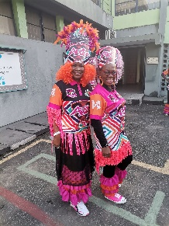** 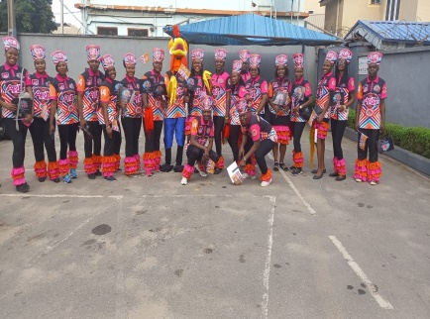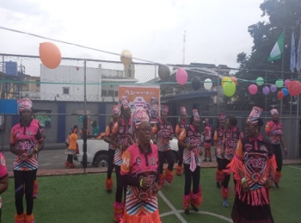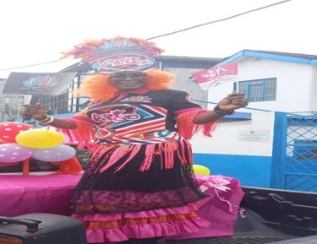

**** 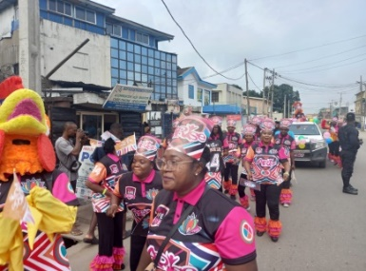 ** **

** 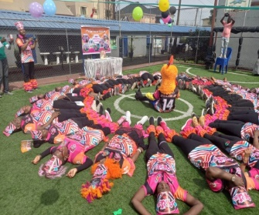 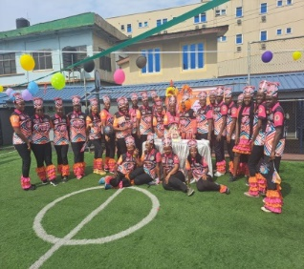 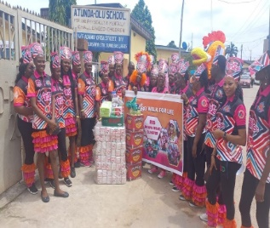 **

** 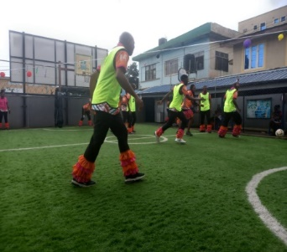 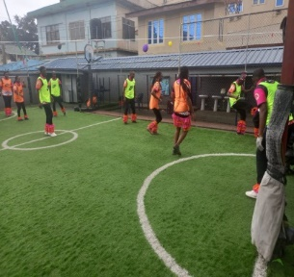 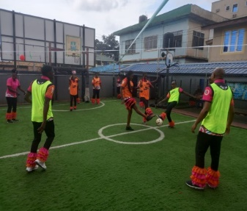**

**On Saturday, 15th October, 2022, the 14th edition of the ARISE WALK for Life was held globally. For RIS Apapa Road Cluster, the event had all the trappings of a carnival and party. It was really an exciting time and a great platform to showcase walking as a form of exercise.  
 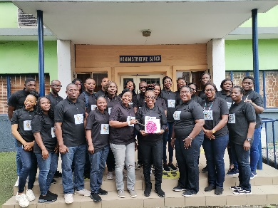   **

**The Teachers’ Day Out to cap the 3-day celebration of this year’s Teachers’ Day was filled with loads of fun. Teachers visited the Lekki Conservative Centre. The memories of the Canopy Walk made the outing truly worthwhile! Many thanks to the Board of Governors, the Head of School, and the PTF for celebrating the teachers.**

**SCHOOL BUZZ CONTINUES...**

**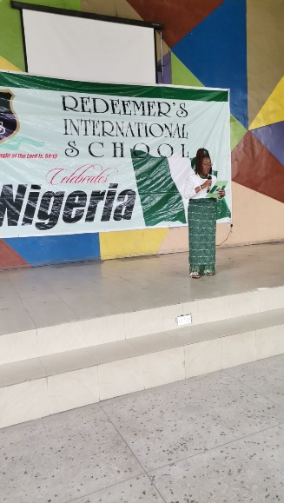 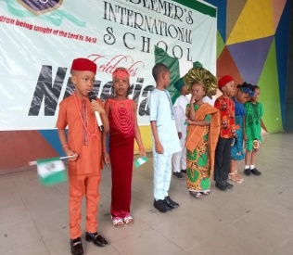** 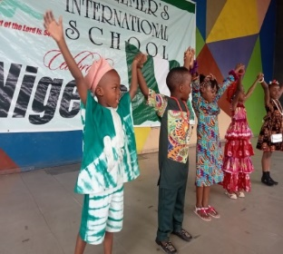 **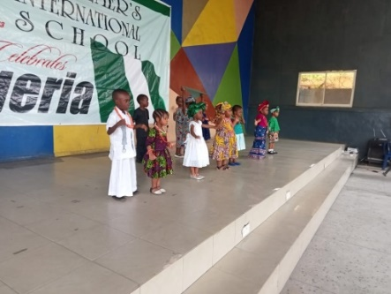 **

**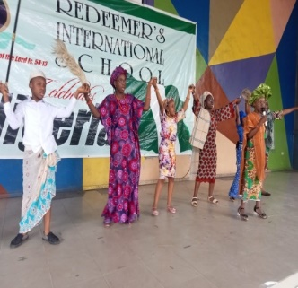 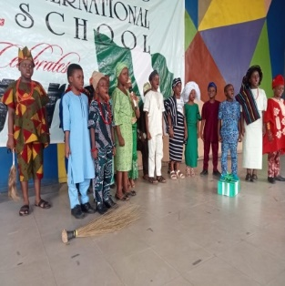 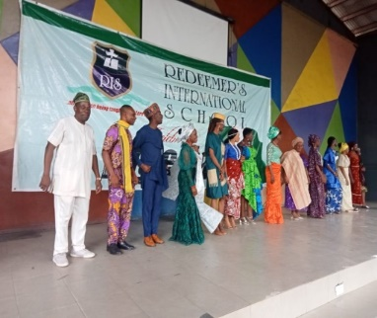 **

**A School wide National Day celebration was held on Friday, 30th September, 2022 with pomp and pageantry. The staff and pupils were dressed in attires reflecting various ethnicities in Nigeria. The Day was capped with a Food Fair that had various sumptuous local delicacies**.

****

**Members of the Pupils Representative Council (PRC), held their first meeting for the session with the Senior Leadership Team on Thursday, 20th October, 2022. They introduced themselves and briefly discussed their plans for the new session.**

**OTHER NEWS**

|  |  |
| --- | --- |
| **ALUMNI**: Know any of our alumni doing well in academics in their secondary school or done with secondary and tertiary education but is flying high? Please give us the details of such an alumnus so we can celebrate our own and further encourage our current pupils to strive for excellence. | **NEWEST ADDITIONS TO OUR FACULTY:** The school has employed a new teacher to join the Nursery Section – Mrs. Joy Onyia.  We have equally hired a new First Aider, Ms. Elizabeth Ibanga to replace Mr. Edet Ekpeyong, who moved on to greener pastures. |
| **CLUB MATTERS:** The aura of creativity sweeping through our clubs brings with it a refreshing feeling. No doubt, pupils would have wonderful tales to tell about their club. Ask your child about his or hers. | **VISITATION FROM REGULATORS:** In the course of the first half of this term, the school had visitations from the Federal Fire Service and Environmental Sanitation Unit of LMLG. The school received 5 Star ratings from both agencies. |

|  |  |
| --- | --- |
| **GRIEVANCE PROCEDURE**  We would like to bring to your notice the  grievance procedure in the school. Please  avoid any open confrontation with your  child’s teacher, classmates or other parents. Anything related to your child’s work or performance should first be discussed with your child’s class teacher. If you are not satisfied, please see the Lead Teacher in your child’s section. If you are still not satisfied, see the Deputy Head of School and where still not satisfied, you can see the Head of School. Where the issue is finance related, please see the School Bursar, Mrs. Adejoke Babalola. You can also write your complaint in the Complaints Book with the Bursar. The School’s Senior Leadership Team comprises of:  **PRECIOUS TAIWO-**08033544052  **LEAD TEACHER-NURSERY**  **.........................................**  **DOROTHY JAJA-**08023965077  **LEAD TEACHER-LOWER PRIMARY**  **.........................................**  **BABAJIDE OGUNDIPE-**08055424089  **LEAD TEACHER-UPPER PRIMARY**  **........................................**  **ADEJOKE BABALOLA-**08098057912  **SCHOOL BURSAR**  **...........................................**  **OLAYEMI AZEEZ-**08023288594  **DEPUTY HEAD OF SCHOOL**  **.......................................**  **ANNE BESSONG-**08079805581  **HEAD OF SCHOOL** | **PLEASE BE REMINDED THAT:**  **\***Only light foods are allowed as breakfast/lunch for pupils in the school. Parents/Guardians should please take note that solid foods are not allowed at all.  \*Birthday parties are celebrated in RIS with only cake and packet/plastic drinks. Party packs, snacks outside what has been specified above are not permitted for staff and pupils  \*Pupils are allowed to bring cooked food to school, so parents are implored to have their food in food warmer that could keep the food warmed till break time.  \*Nursery pupils are not allowed to put beads in the hair, only ribbons are allowed.  \*All pupils are to come in through the Decontamination Booth at the front gate in the morning.  \*Late pick-up (From 4:31pm) attracts a penalty of N500.00 per family.  \*Braids or use of attachment is not allowed. Girls should have their hair neatly plaited and boys’ hair cropped.  \*Vehicles are not allowed in the school compound. All children are dropped at the entrance of the walkway. The very little Nursery pupils are escorted to their classes by RIS Staff at the gate.  \*Parents are not allowed in the classroom blocks from 7:45am -2:10 pm for Primary and 1:00 pm for Nursery.  **\*PLEASE CHECK THE PUPILS’ HANDBOOK FOR A COMPREHENSIVE KNOWLEDGE OF RULES GUIDING**  **PUPILS IN RIS.**  **SIGNED**  **ANNE BESSONG**  **HEAD OF SCHOOL** |